Can Old War Dogs Still Hunt?
Born in 1892 the 7X57mm military cartridge with its standard 173gr bullet was adopted by a number of nations including Spain and of course by our very own Boer republics. It changed the course of firearm history when the Spanish used it to inflict huge casualties on the United States troops during the Spanish/American war in 1898 and shortly after this it became a legend in the hands of Boer marksmen during the Second Anglo-Boer War. The .303 British, which was the 7X57mm’s adversary from 1899 to 1902 on our home soil, went on to become the longest serving military cartridge in the world, making it’s real fighting debut here and going on to fight two world wars and countless medium sized and smaller conflicts around the world. When South Africa went metric after 1971 it was (almost!) a crime to use swearwords like “inches” or “yards” and our locally produced .303 military ammunition became known as the 7,7X56R round. Somewhat confusing but fortunately for hunters sporting cartridges retained their original name and the .303British lived on. The three really successful African hunting cartridges that were adapted from military rounds used in conflict in the late 1800’s and early 1900’s in the southernmost part of Africa were the venerable single shot tilting block 577/450 Martini-Henry and the two aforementioned Anglo-Boer war opponents, the .303 and 7X57. All three have taken innumerable game animals from the tiny Duiker to the mighty Elephant and continue to serve well in the hunting field to this day with even some die-hard Martini enthusiasts proud to strut their stuff.

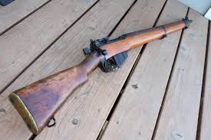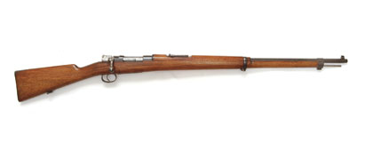
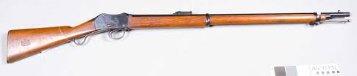

In their early hunting careers the 7X57mm with both solid and soft point 173gr bullets was a popular light bore rifle as was the .303 (which at that time used the effective and deep penetrating 215gr bullet). The 7X57mm became so popular in Africa that the devious British renamed it and marketed it as their own .275 Rigby. As the 7X57mm was a designated light bore the Brits scaled down their bullet weight to 140gr which they regarded as adequate for antelope and for “pot” shooting as well as deer stalking in their own wet misty Island.
The wiser African hunters continued to use the German ammunition in 173gr in definite preference to the new British offering.
At the same time the old Martini continued to belch forth its heavy (up to 500gr) lead bullets and more often than not, by the time the smoke from the black powder had cleared, it’s quarry had breathed a last breath and the job had been done.
In its solid format the 173gr 7X57mm was considered by talented ivory hunters as adequate for carefully selected brain shots on Elephants with solids and with soft points on antelope up to and including Eland and sometimes rather foolishly, Buffalo. Today it continues to be one of those calibers that in some mystical way still boxes way above its weight class.
Modern 7X57mm ammunition is loaded in a number of weights with the most effective for Bushveldt use on animals such as Kudu and Wildebeest still being the 175gr although the new breed of hunters, who insist on shooting from distances further than 150 metres, seem to prefer the lighter bullets.
The bad rap given to the .303 in later years was due to the extensive use by hunters of the lighter 174gr military round which was never intended to be used on game animals as it was designed to tumble on impact with human targets rather than to penetrate in a straight path - which is obviously a pre-requisite for a game hunting bullet. In the sad absence of its best performing factory loaded heavy 215gr bullet the .303 has still done good work, at least for me, in the Winchester 180gr Power-Point offering, although other factory loads in 174gr, 150gr or even 130gr configuration have a loyal following and seem to get their respective jobs done well.
Having come full circle from 1879 when Martini’s ruled at Rorke’s Drift to 2015 when we are inundated with growing choices of mega magnums and short super magnums and custom bonded monolithic expanding deep penetrating bullets of what possible use could these three old soldiers be in the hunting field?
Well, we can simply emulate our forebears and shoot all our game with any of the three – each of which will do the job if the man behind the gun does his bit. Admittedly getting close enough to open plains game may be a tad difficult for the Martini but the other two calibers continue to lay low legions of Springbuck and more than their fair share of other plains game while anything in the bush under a hundred yards is biltong on the hoof for the Martini.
All right you say but what about dangerous game?
While not the ideal choice for the animals that can fight back with tusk, horn, jaw or claw, a cool head with his single shot Martini loaded with hardened 500gr lead bullets will be entering the jousts as a brave man willing to take a 20 yard heart shot on an Elephant or Buffalo. A magazine full of 215gr hand loaded Woodleigh .303 bullets should be worthy challengers for an adventurous Lion hunter while the 7X57mm spitting out its 173gr bullets could still do the job for a bold man seeking his tom Leopard. Of course all this assumes that today’s hunter is made of the same stuff as his ancestors, who performed these feats with these very rifles on a pretty regular basis, often without more back-up than a spear wielding tracker. This would really put danger back into dangerous game hunting with the added spice of being able to repeat history with an old warrior in your hands. Do any of us still have what it takes? It surely makes a McNab seem pretty tame. Fortunately for prospective widows most African states won’t allow you to experience the adrenaline high of repeating history on dangerous game with these fine calibers but that does not detract from the former glory of these old war dogs who would all be happy to bark once more at the mighty beasts. Hold that thought while still trying to …
Stay safe
Louis Steyn
February 2015

